Downloading the app to your mobile phone
Step 1 – Please go to your app store to download the Teacher2Parents app
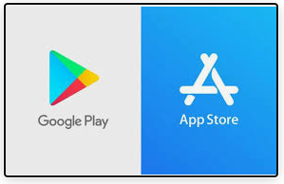
Step 2 – The Teacher2 Parents app will appear as below

Step 3 – After the app has loaded to your phone, please follow the instructions on screen
Step 4 – Enter your mobile number
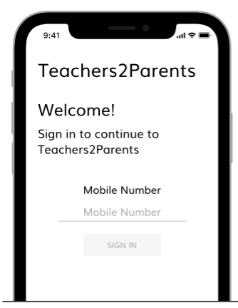

Step 5 – Wait for a message to be received on your phone, this is a 6 digit number e.g. 123456
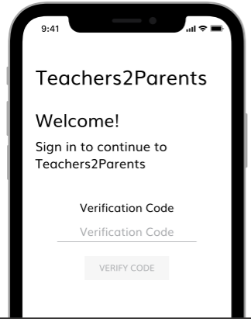
Step 6 – Enter the 6 digit code into the app and press verify
You have successfully loaded the Teacher2Parent app onto your phone.

Making a payment using you Teacher2Parents app
Step 1 – Open the app
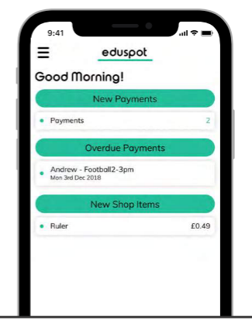
Step 2 – In the left corner you can see three Lines, click on this to access Dinners, Shop (Uniform), trip payments etc.
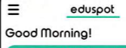

Step 3 – To pay dinner money click on the three lines, then choose Dinners
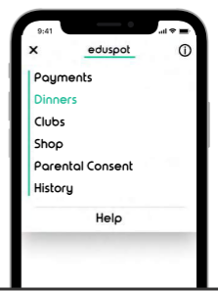
Step 4 – Once the screen is opened you will see £12.50 payment showing, this can be changed to a different amount by clicking on the box.
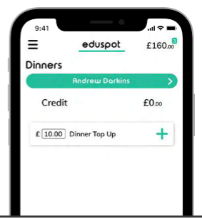
Step 5 – Once the amount has been entered please click on , to add the amount to your basket.

Step 6 – Checkout your basket by clicking on the amount in the right hand corner. Once the basket has opened click on Pay
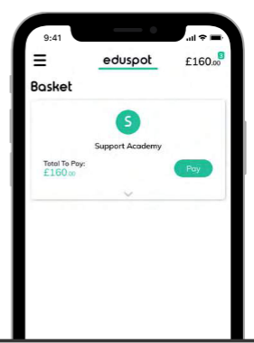
Step 7 – A new screen will open for payment details to be entered, once all details have been entered please click on pay now.
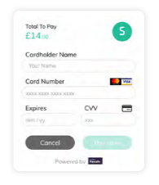

Paying using barcodes
All parents have been issued a bar code in case they do not have access to a mobile phone.

Step 1 – Choose the nearest PayPoint shop

- St Ann’s Convenience Store
St Ann’s Road
- Loco (Petrol Station)
Fitzwilliam Road
- Haji & Son
Hatherley Road
- Select Convenience
College Walk
- Simply Local
Middle Lane

Step 2 – Hand the cashier the barcodes and clearly explain what you are wanting to pay and how much you are paying i.e.
Dinner’s 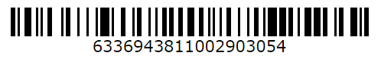(This bar code will not work)

Step 3 – The cashier/shop will then give you a receipt for your payment
Step 4 – If you cannot locate your bar codes please telephone reception, this will be passed to the pupil in class

